**USER GUIDE CSCI 6461**

**TEAM 02**

1. The following user guide is for a Simulator developed by Team 02.

Content of zip file

* Source Code(Simulator.java, Compution.java)
* Design Notes
* User Guide

Requirement

* Java

Starting the Program

There are two way to start the program

* Through the terminal



* Through File Explorer
  + Directly Click the Highlighted Jar File in your File Explorer(similar to the one pictured below)

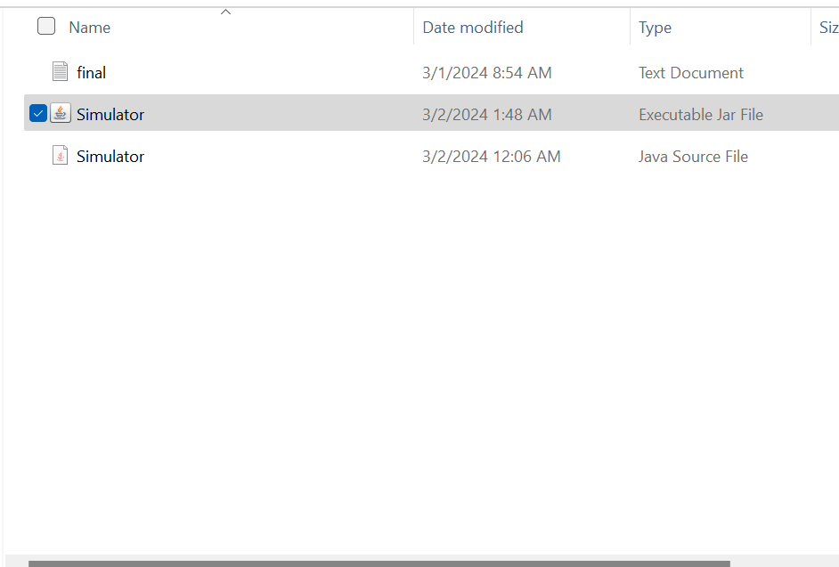

Running the Code/Start-Up

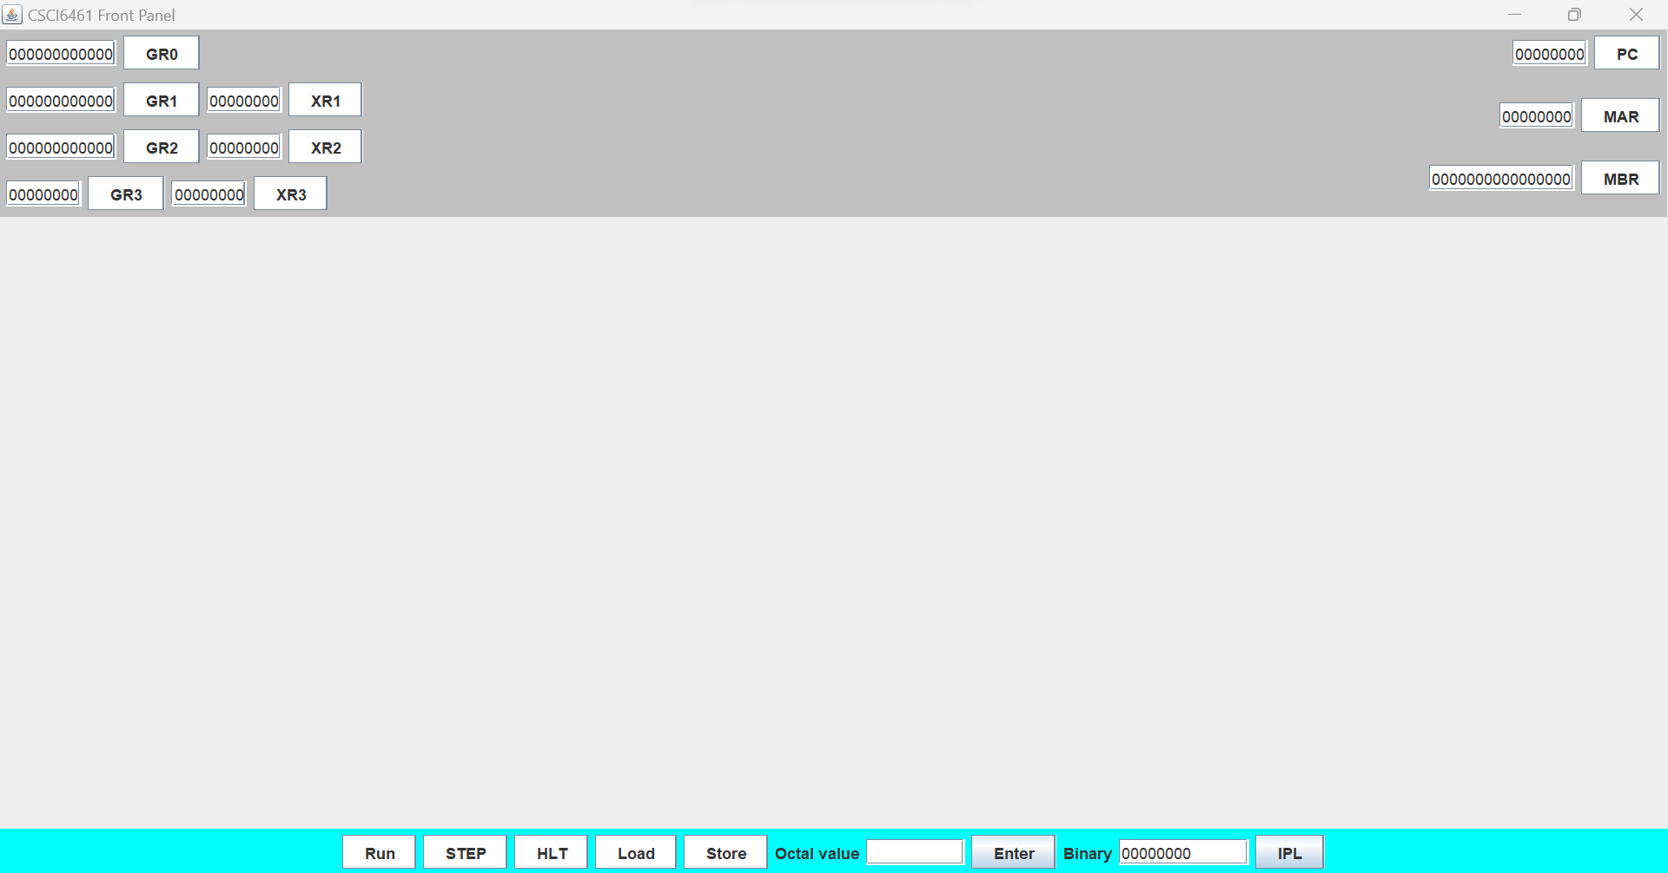

Picture above is the simulator on start. All the button and input fields need are available on start-up. The frame must be in full screen to see all available options. The application is comprised of Text Fields and Buttons. Some Text fields have accompanying buttons such as…

* GR0 – GR3 (General Purpose Registers)
* XR1-XR3 (Index Registers)
* PC (Program Counter)
* MAR (Memory Address Register)
* MBR (Memory Buffer Register)

Loading Data

Data can be inserted into any of the Text Fields within the grey region. In order to do, one must first input their value of interest into the “Octal Value” input field and then press “Enter”. It is important to mention that the input field accepts values in octals. After pressing “Enter”, you can see the result in the Binary input in binary form.



Now that the value is in the Binary field, you can place it into any one of aforementioned fields simply by pressing its corresponding button. For example, in order to put the value in General Register 0(GRO), simply just select the “GR0”. The value will then appear in that space.

Store Data Into Memory

In order to store data into memory, you must first detail the memory location you it to be in. This done by entering an octal value and then loading that value into the MAR input field (refer to the last section for details). Do the same for the MBR field. Afterwards, press the “Store” button. Now, you have inserted a value into memory! Now we will show you an example.

Here, we will be inserting the value 5 into memory location 3.

* Insert 3 into the “Octal Value” and press “Enter”
* Click the MAR button
* Insert 5 into the “Octal Value” and Press Enter
* Click the “MBR” button

If you screen looks like this, you can now press “Store”. You have successfully entered data into memory!

Loading Data From Memory

It is recommended that data has been stored in data before hand before performing this task. In order to data from memory. Simple enter the memory address you want to get content from in the Octal Value, hit “Enter”, and then hit the “MAR” button. Finally, once the value is in the “MAR” input field, hit the “Load” button. The contents of the memory address should appear in the “MBR” input field.

Inserting an Input File

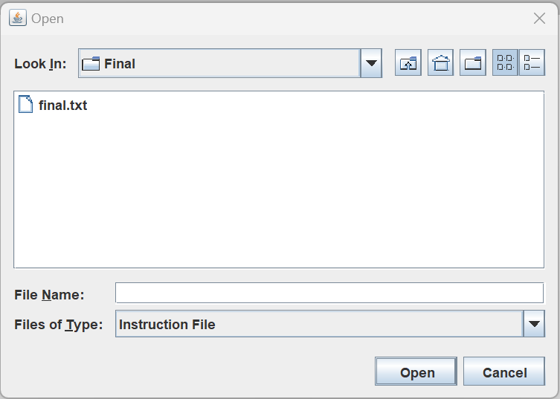The input file should usually be the outcome of an assembler (Look at the user guide for the Assembler). When you click the IPL button, a file explorer will appear. Will there search for your input file. This program only accepts input files with the .txt extension. Once the file is open, you will see the first instruction is completed and visualized in the simulator. Now that the file has been entered, the “Run” and “Step” button are available now.

File Explorer

Now when you click the “Step” button, another line from the input file will be run and visualized on the simulator. If you use the “Run” button, you will notice that the entire file will run, and the last instruction in the input file will be executed and visualized. While, instructions are actively running, you can click the “HLT” button to stop the code from running I suddenly with the last instruction being executed displayed.